**EXPERIMENT NUMBER –9**

**Student Name: Shinde Smita Shahaji UID: 20BCS4643**

**Branch: CSE (IOT) Section/Group: IOT (Group-B)**

**Semester: 2nd semester Date of Performance:04/30/2021**

**Subject Name: Quantum and Semiconductor physics lab**

AIM OF THE EXPERIMENT –

Determination of value of Planck’s constant ‘h’ using photo cell.

APPARATUS-

|  |  |  |  |
| --- | --- | --- | --- |
| Sr.No. | Equipment | Range | Quantity |
| 1. | Digital Voltmeter (DVM) to measure the voltage across the LEDs | 0-20V | 1 |
| 2. | Micro-ammeter to determine the current through LEDs | 30 µA | 1 |
| 3. | Jack J to connect the LEDs | Different colors | 4 |

Diagram

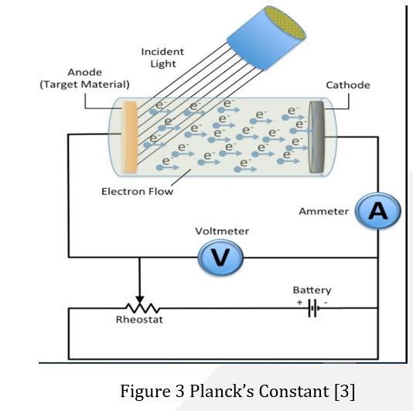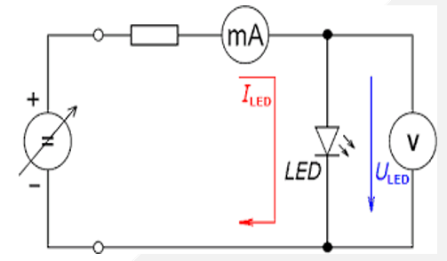

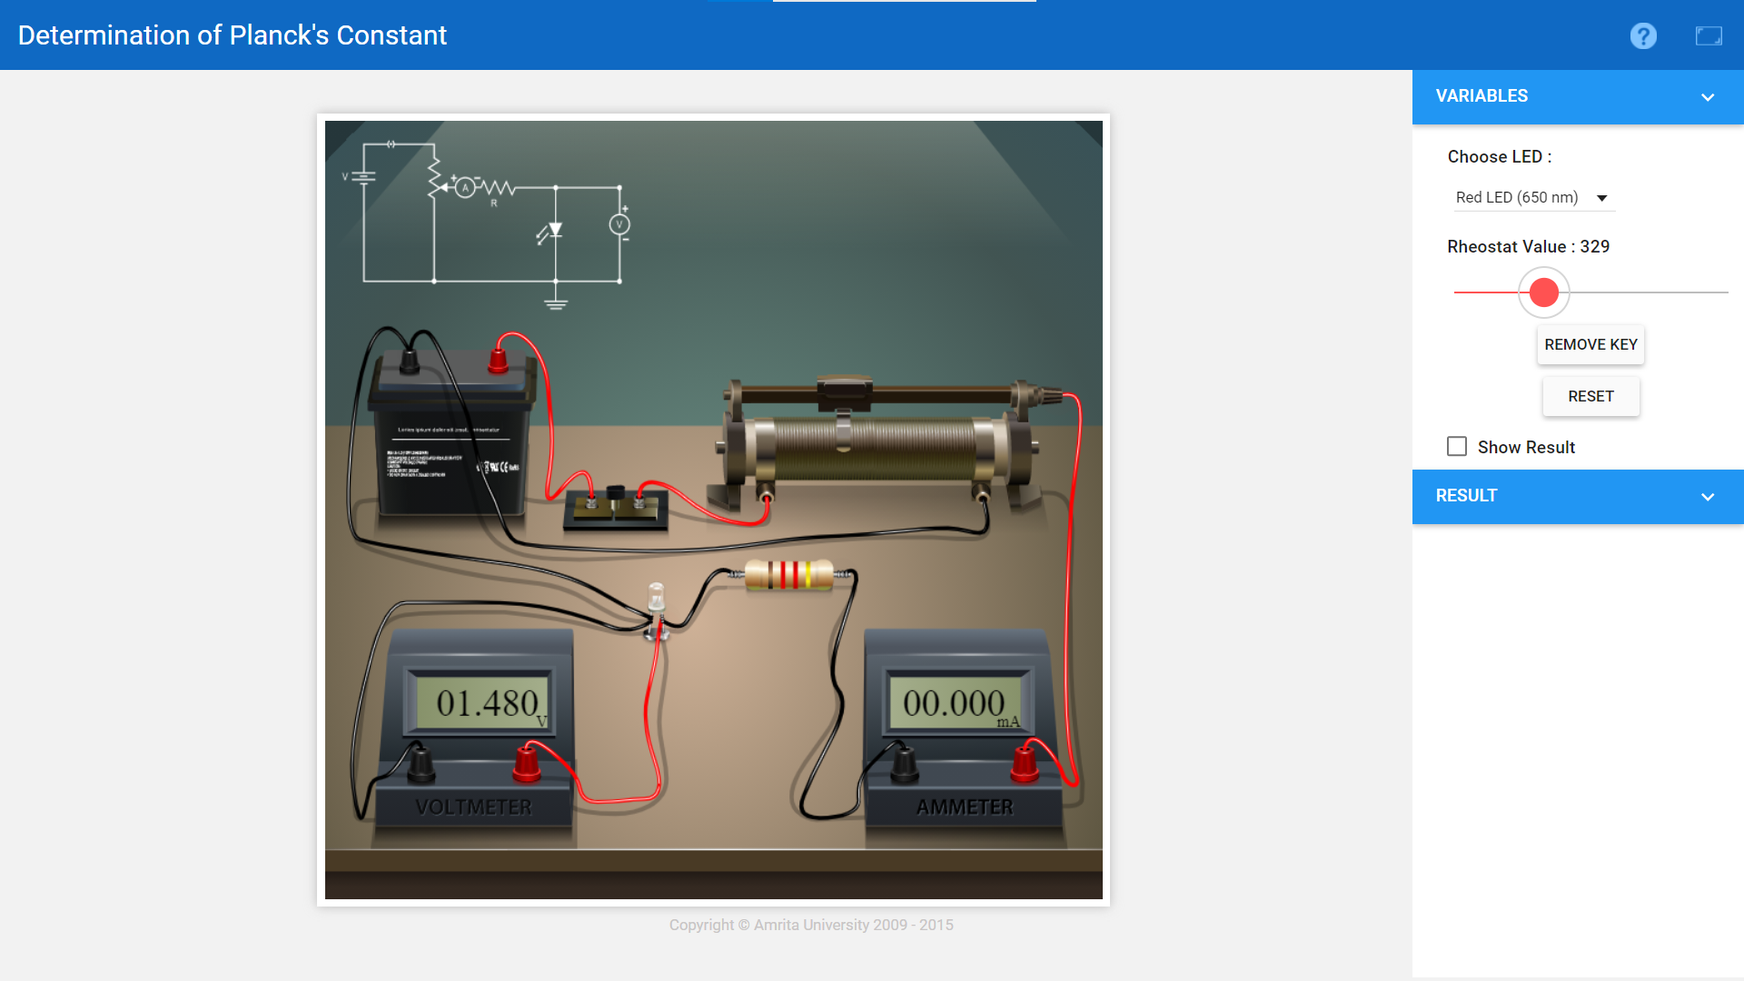

Formula Used

E= hʋ (1)

E=eV (2)

Where e = 1.6 × 10-19 C

υ=c/ λ

Where c = 3 × 108 m/sec

We then get:

h=eV λ/c (3)

V=hc/e λ (4)

It is this equation that we will use to determine Planck's constant.

Where h is Planck’s Constant, ʋ is the frequency of light

υ=hc/e λ

|  |  |  |  |  |  |  |  |
| --- | --- | --- | --- | --- | --- | --- | --- |
| Sr.no | L.E.D. Colour | Wavelength  λ (nm) | 1/ λ | Stoppage Voltage  V (volts) | Energy (J) E=eV | Frequency  υ = c/ λ | h=eV λ/c |
| 1 | Red | 650 | 0.0015 | 01.908 | 3.05*10^-19 | 461500 | 6.614*10^-34 |
| 2 | Green | 510 | 0.0019 | 02.434 | 3.89*10^-19 | 588200 | 6.621*10^-34 |
| 3 | Yellow | 570 | 0.0017 | 02.178 | 3.48*10^-19 | 526300 | 6.621*10^-34 |
| 4 | Blue | 475 | 0.0021 | 02.615 | 4.18*10^-19 | 631500 | 6.620*10^-34 |

OBSERVATIONS-

CALCULATIONS-

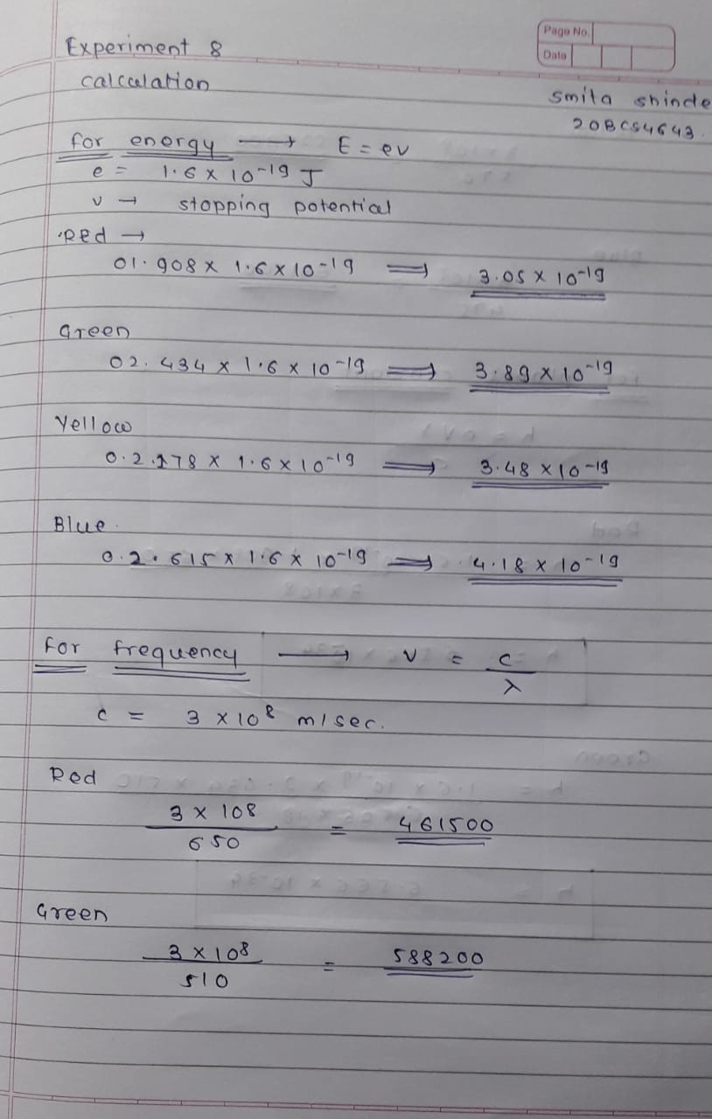

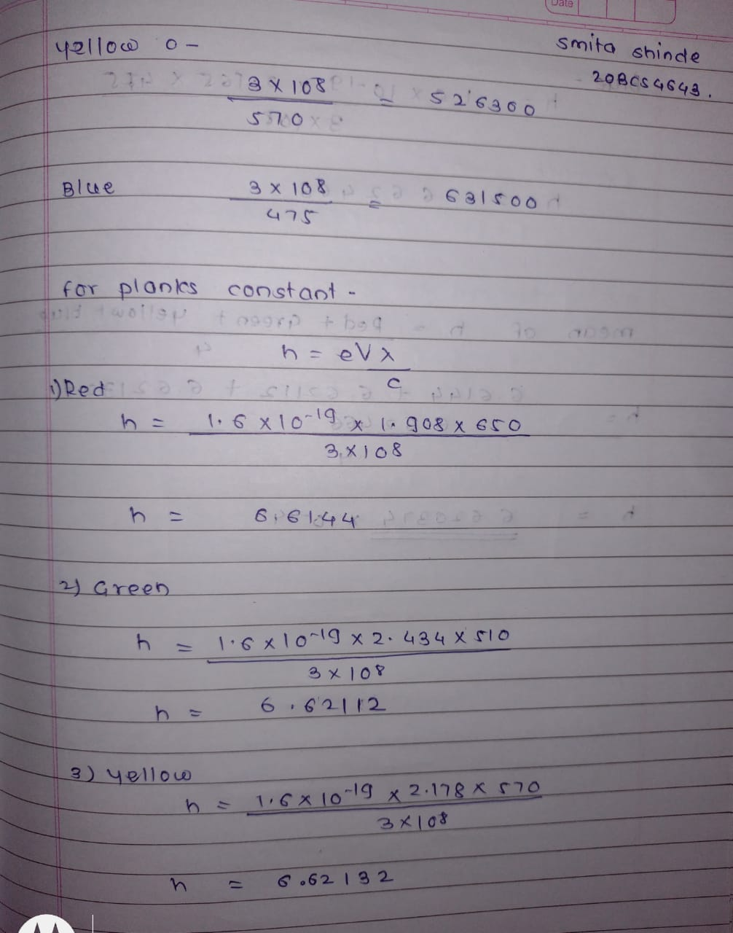

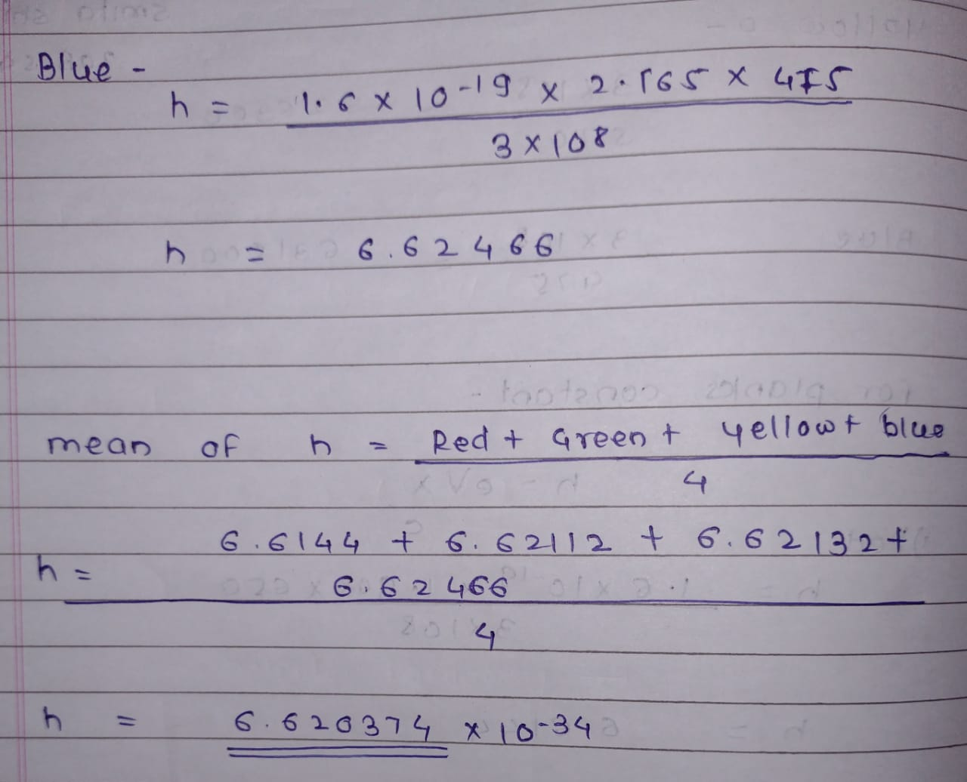

PERCENTAGE ERROR-

No any percentage error

GRAPH (ATTACH IF ANY)-

No graph

SOURCES OF ERROR-

* The experiment should be performed such that the glow of LEDs is properly visible.
* The value of voltmeter and ammeter should be noted with least count.
* The surface on which the apparatus rest should be flat with no surface leakage.

RESULTS AND DISCUSSION-

**Result (s):**

The value of Planck’s constant ‘h’=6.62037*10^-34 Js

**Conclusion:** Our experimental value of Planck’s constant was well within the limits set by experimental uncertainty

LEARNING OUTCOMES

|  |
| --- |
| * It will provide the modest experience that allows students to develop and improve their experimental skills and develop ability to analyze data. |
| * Ability to demonstrate the practical skill on measurements and instrumentation techniques of some Physics experiments. Students will develop the ability to use appropriate physical concepts to obtain quantitative solutions to problems in physics. |
| * Students will demonstrate basic experimental skills by setting up laboratory equipment safely and efficiently, plan and carry out experimental procedures, and report verbally and in written language the results of the experiment. |
| * Students will develop skills by the practice of setting up and conducting an experiment with due regards to minimizing   measurement error. |

EVALUATION COLUMN (To be filled by concerned faculty only)

|  |  |  |  |
| --- | --- | --- | --- |
| **Sr. No.** | **Parameters** | **Maximum Marks** | **Marks Obtained** |
| 1. | Worksheet completion including writing learning objectives/Outcomes. (To be submitted at the end of the day) | 10 |  |
| 2. | Post Lab Quiz Result. | 5 |  |
| 3. | Student Engagement in Simulation/Demonstration/Performance and Controls/Pre-Lab Questions. | 5 |  |
| 4. | Total Marks | 20 |  |
| 5. | Teacher’s Signature (with date) |  | |